Name : Đinh Gia Bảo_SE183741

1. Present the content of manipulating of some command (including syntax, what does it for?, capture two of examples for each command) as

* man :

Explain: Use to display the user manual of any command that we can run on the terminal

Syntax: $ man [OPTION] … [COMMAND NAME] …

Example:

$ man [COMMAND NAME]: It displays the whole manual of the command.

*Example*: $ man man

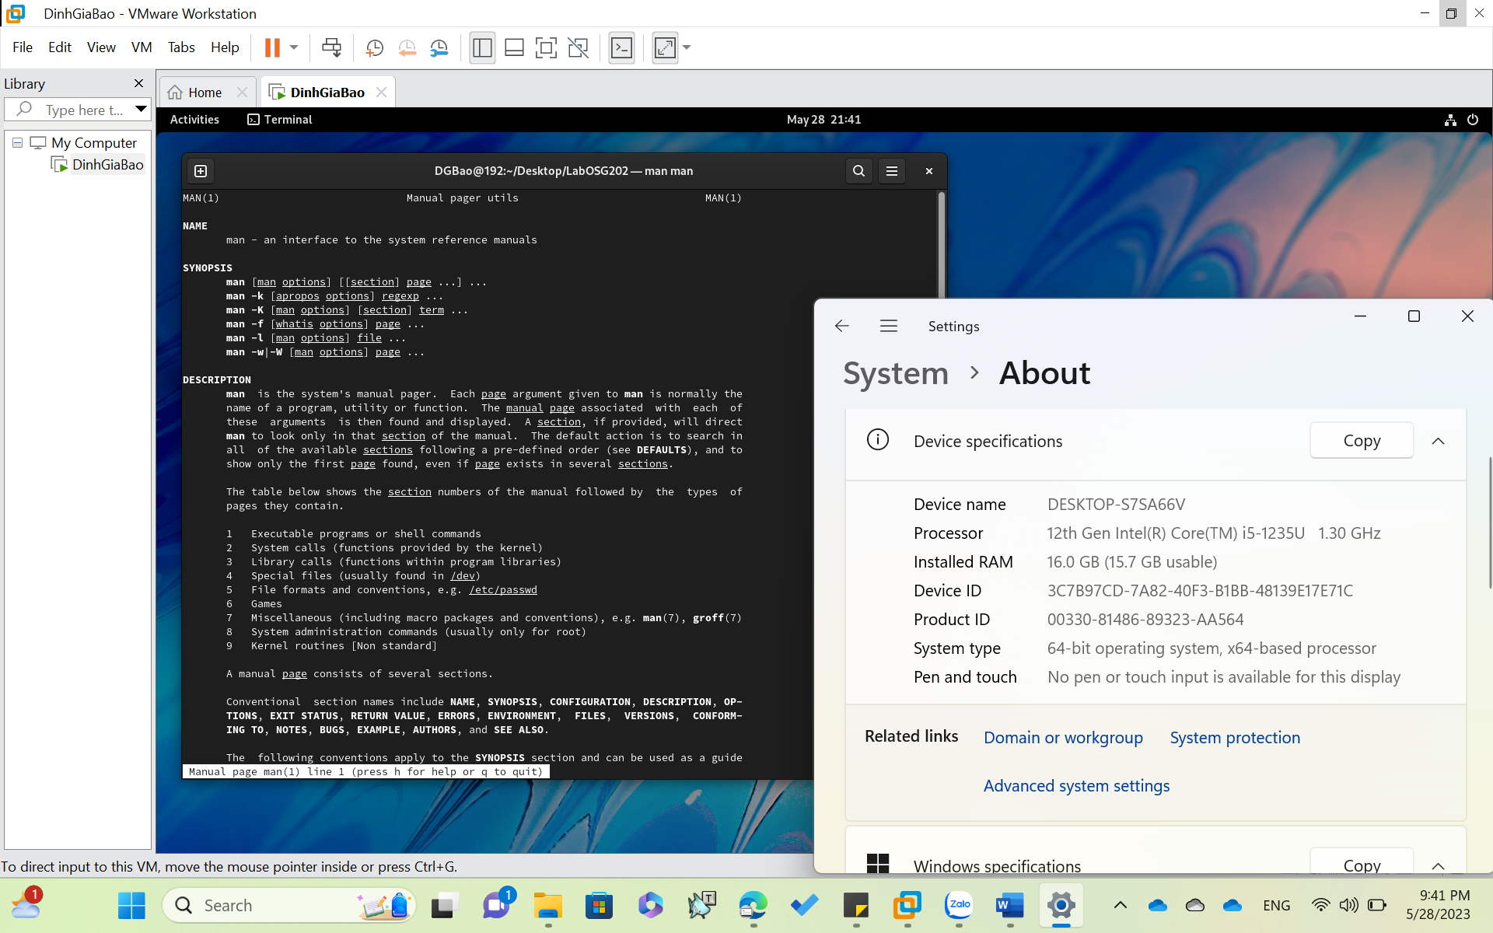

Example: $ man –k [COMMAND NAME]: This option searches the given command as a regular expression in all themanuals and it returns the manual pages with the section number in which it is found

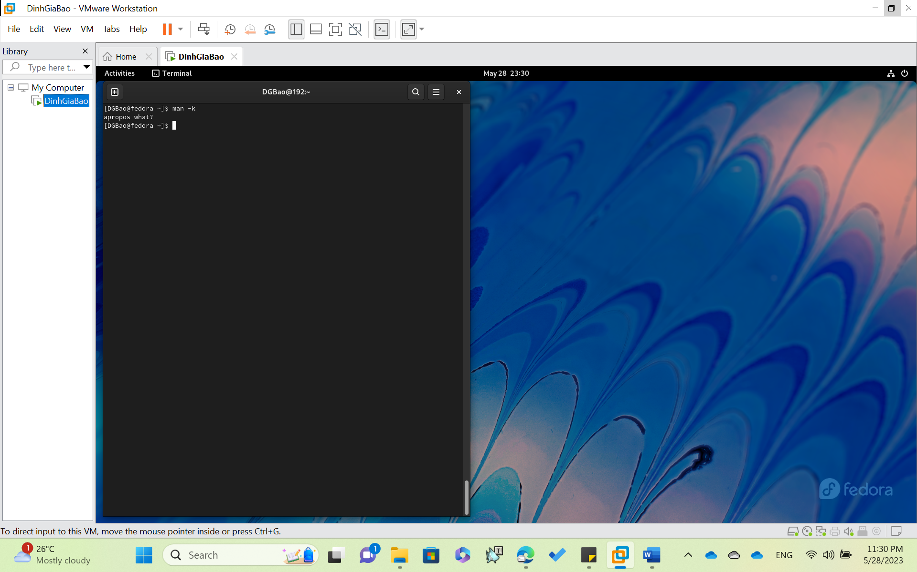

bg:

Explain: bg command in linux is used to place foreground jobs in background.

Syntax: bg [job_spec ...]

Example: bg [JOB_SPEC] : This command is used to put the mentioned job in background.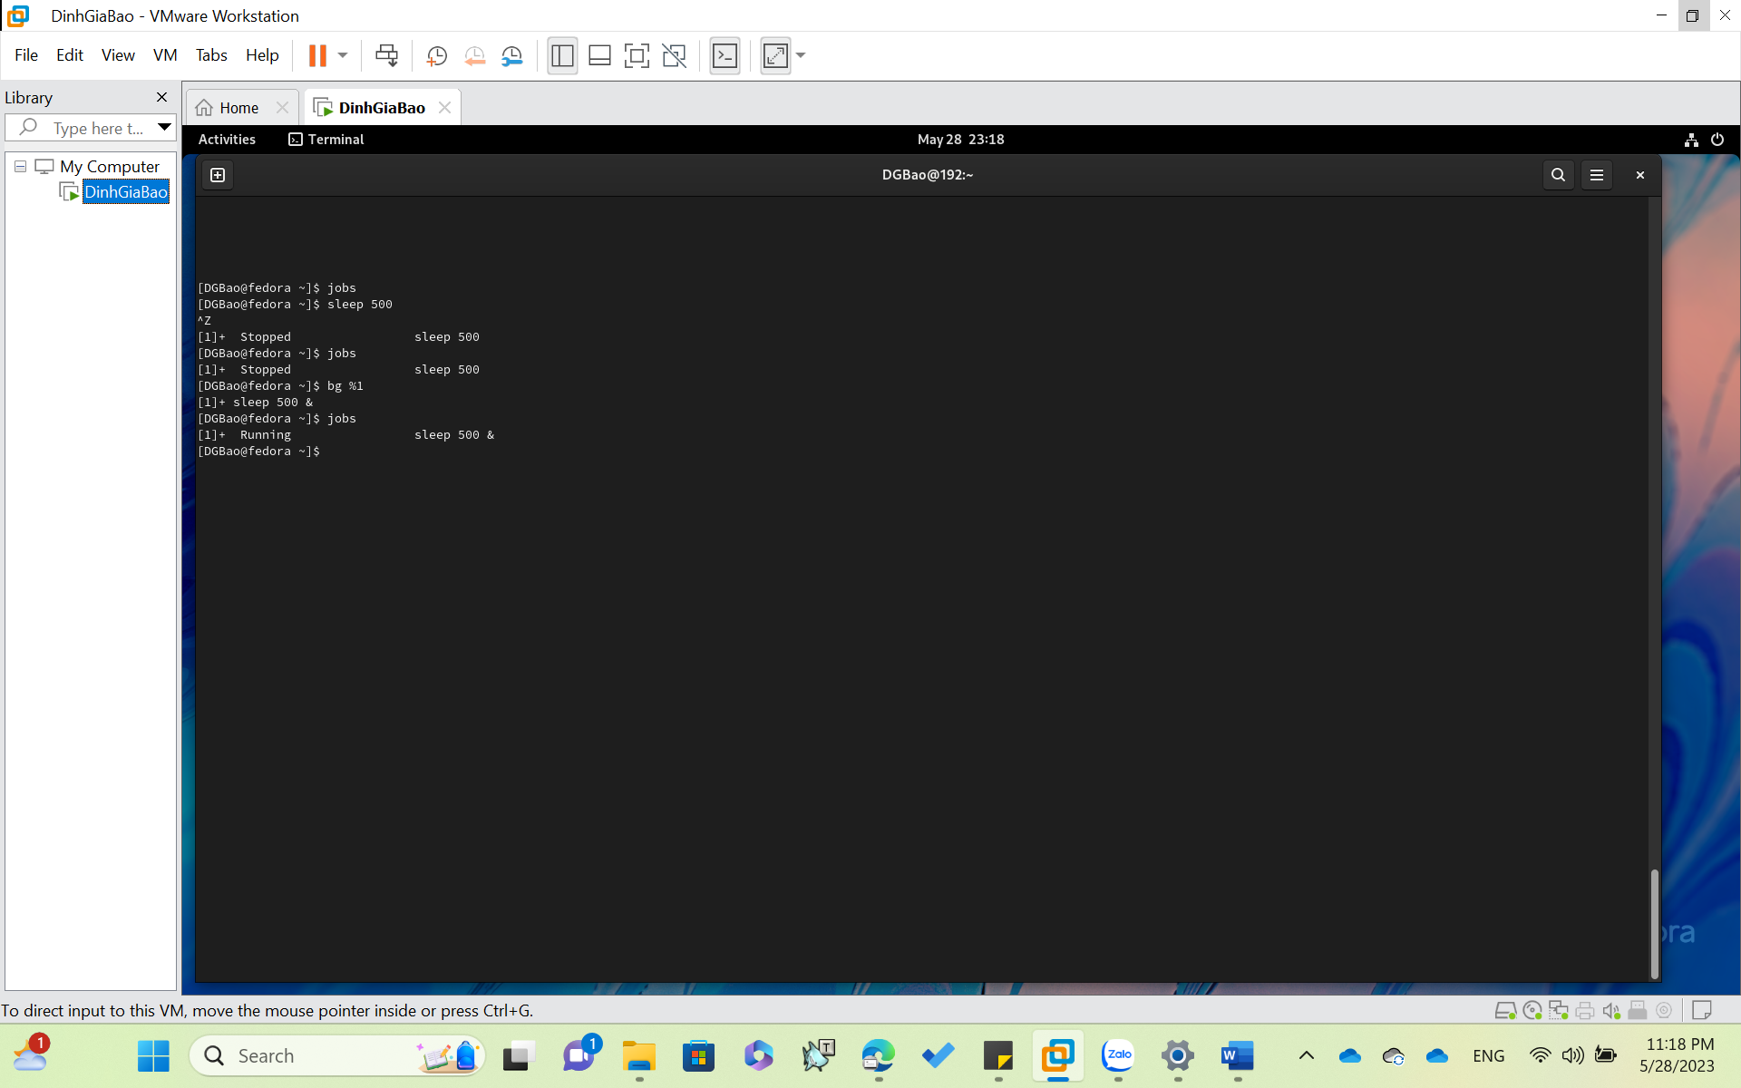

fg:

Explain: fg command in linux used to put a background job in foreground.

Syntax: fg [job_spec]

fg [JOB_SPEC] : This command is used to put the mentioned job running inbackground to foreground.

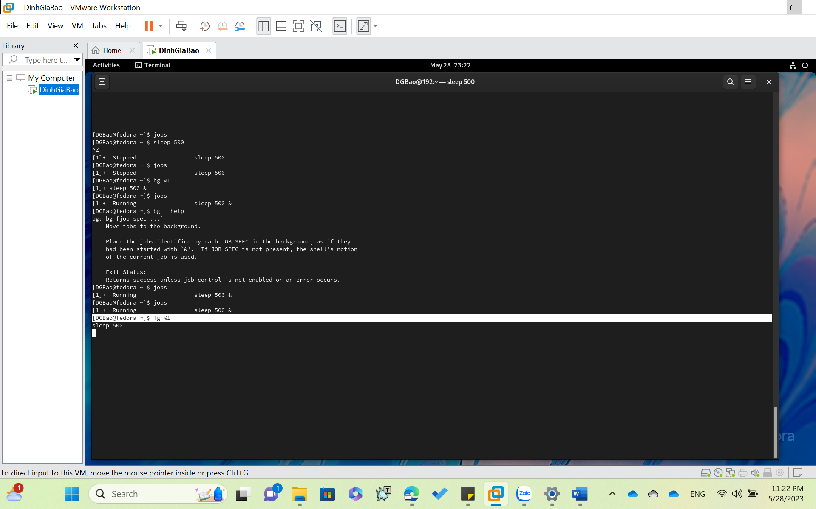

o who:

- Explain: Use to get information about currently logged in user on to system.

- Syntax: $who [options] [filename]

- Example:

$ who : display the following information for each user currently logged in to the system.

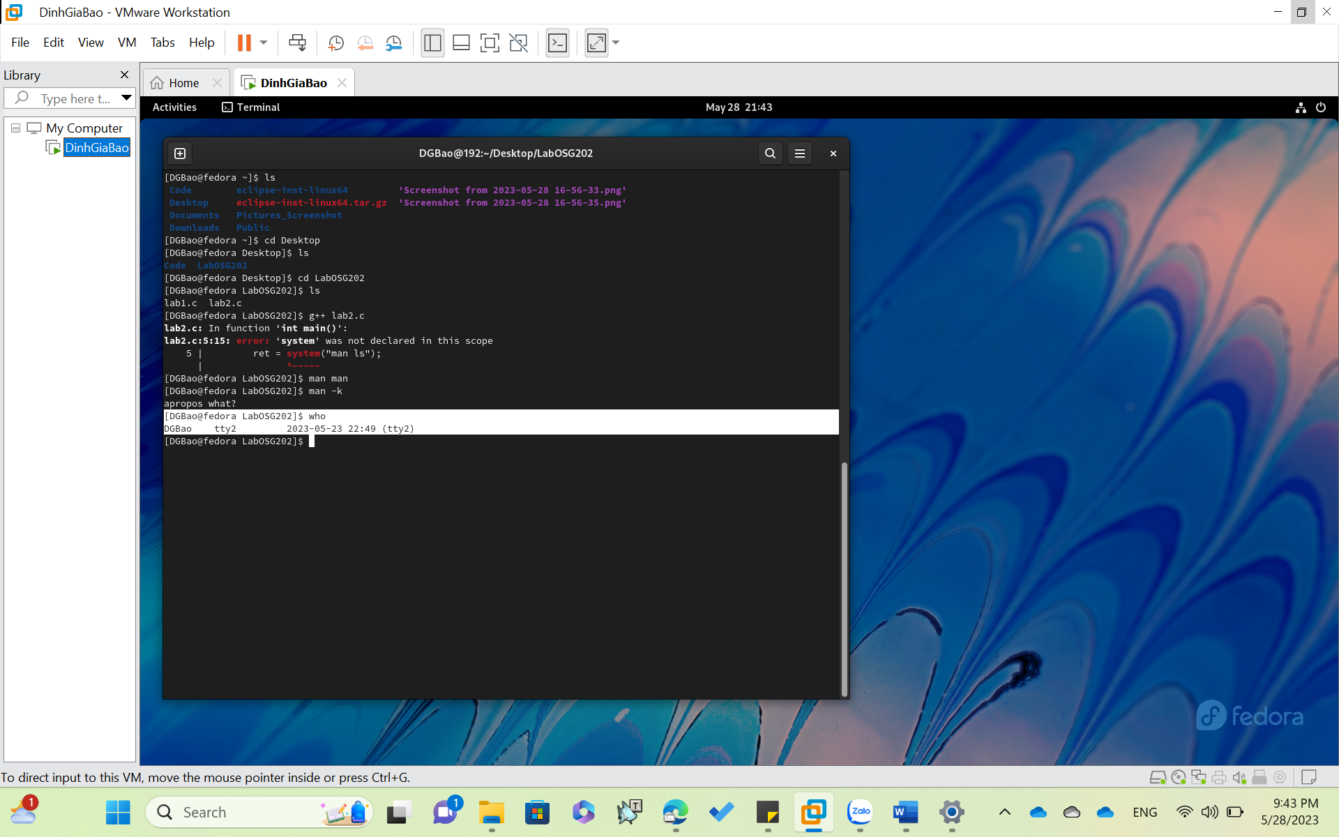

**o chmod**

- Explain: Use to change the access mode of a file.

- Syntax:

chmod [reference][operator][mode] file …

- Example:

chmod u=r hdh

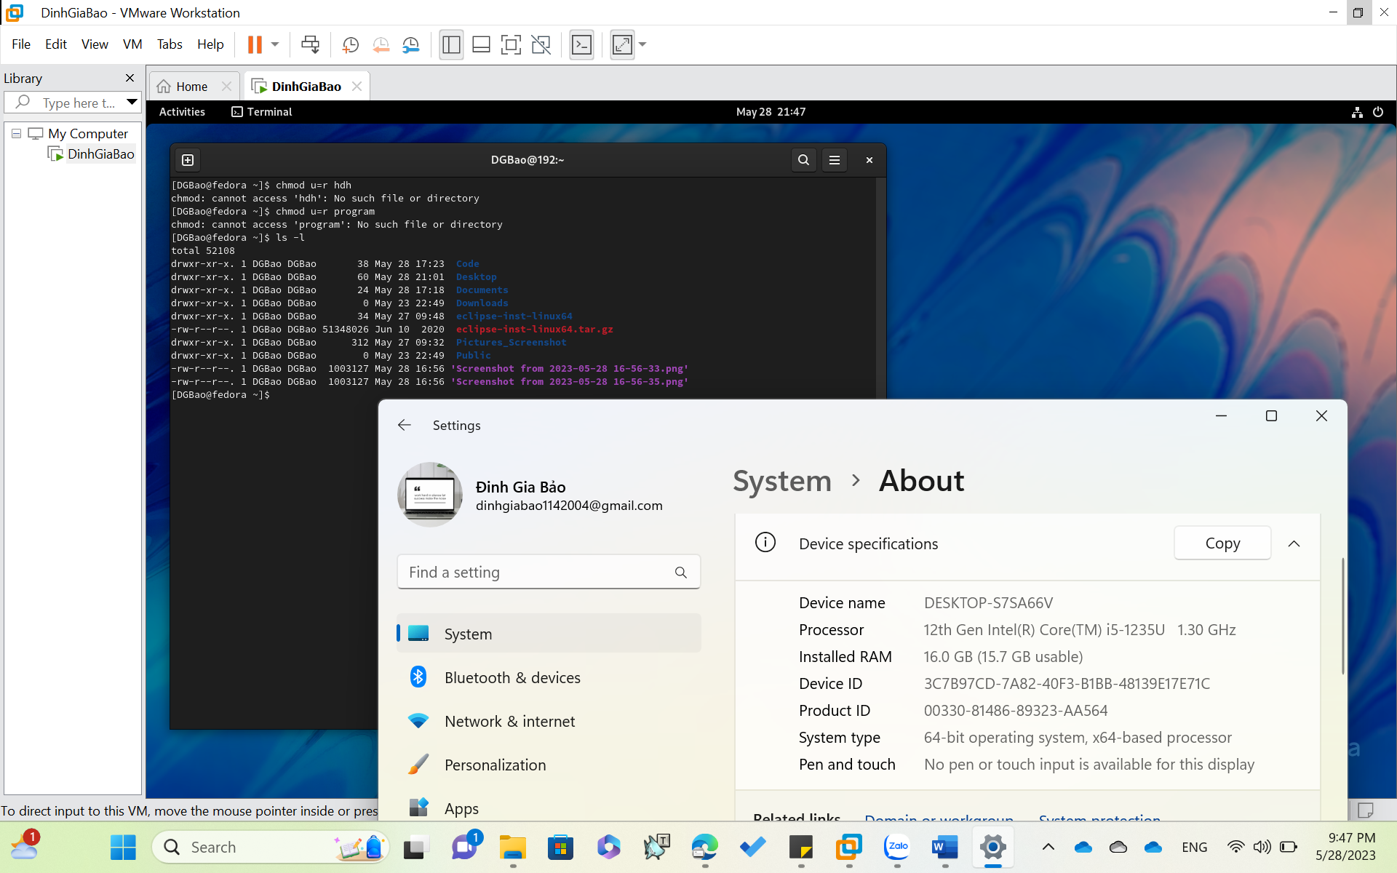

**• date**

- Explain: Used to display the system date and time, also used to set date and time of the system.

- Systax:

date [OPTION]... [+FORMAT]

date [-u|--utc|--universal] [MMDDhhmm[[CC]YY][.ss]]

- Example:

$date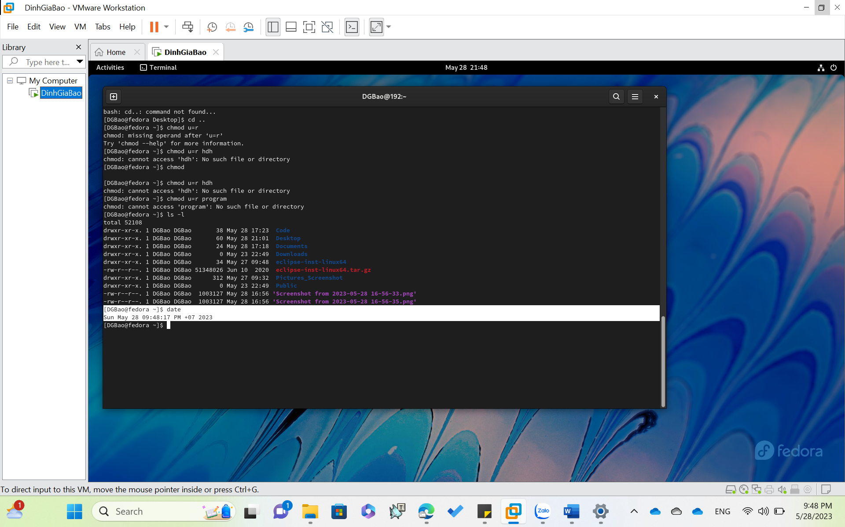

o top

- Explain: used to show the Linux processes. It provides a dynamic real-time view of the running system. Usually, this command shows the summary information of the system and the list of processes or threads which are currently managed by the LinuxKernel

- Example:

$ top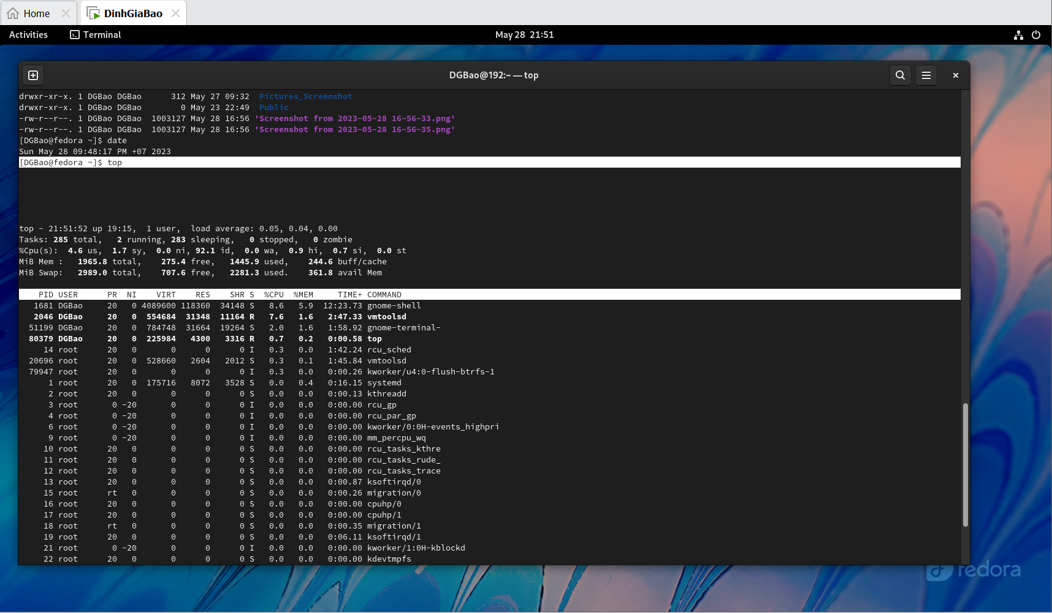

$ top -h: Shows top command systax

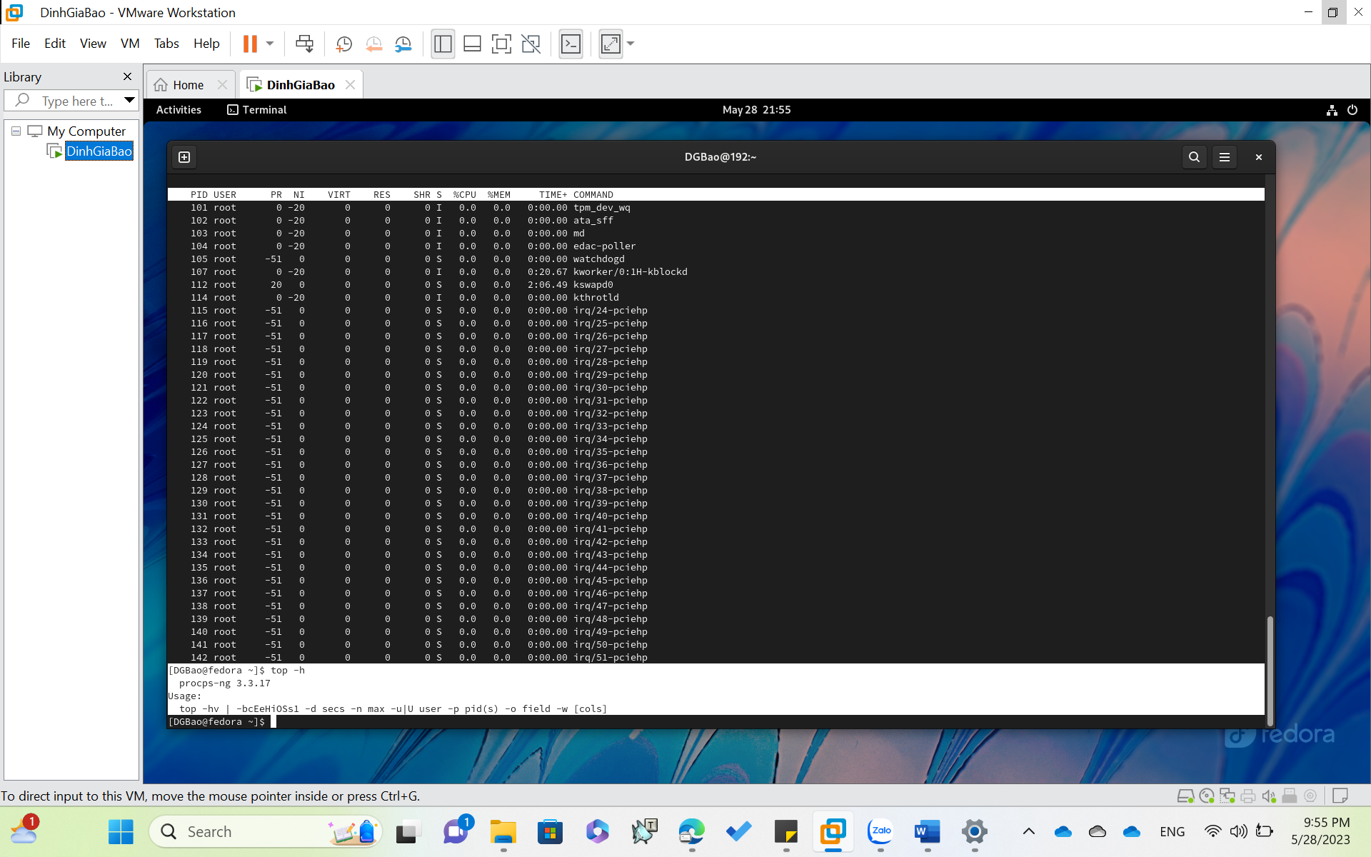

2. Capture the terminal screen using the “grep “nhu nui” thoca.txt” and give your explanation the result. (Notes: thoca.txt is the file in above tutorial)

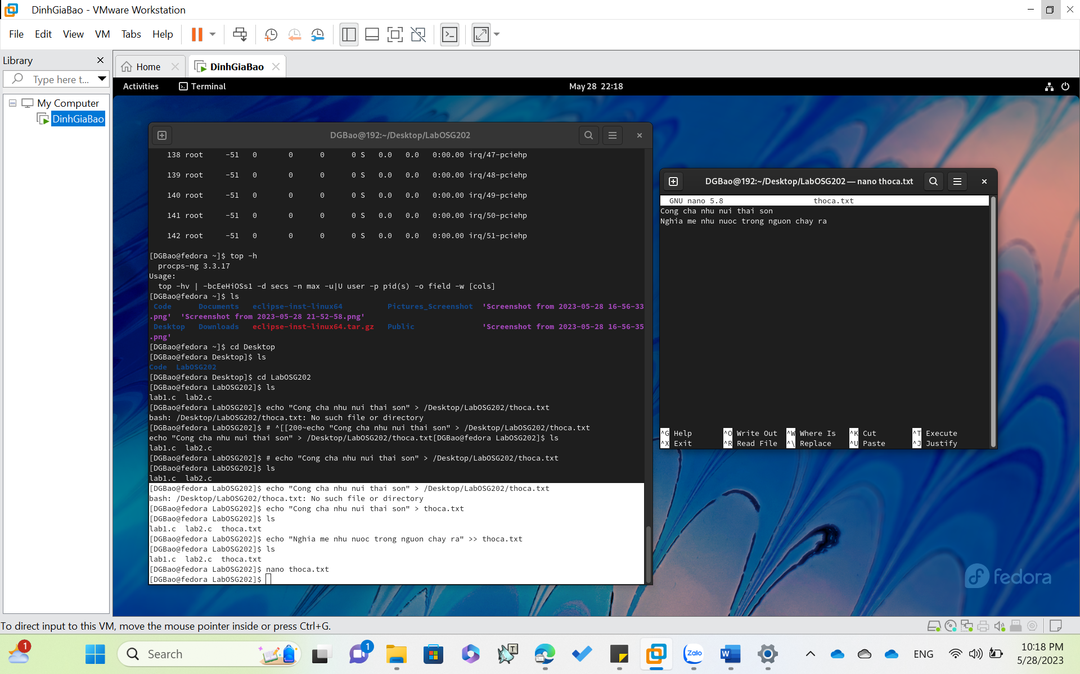

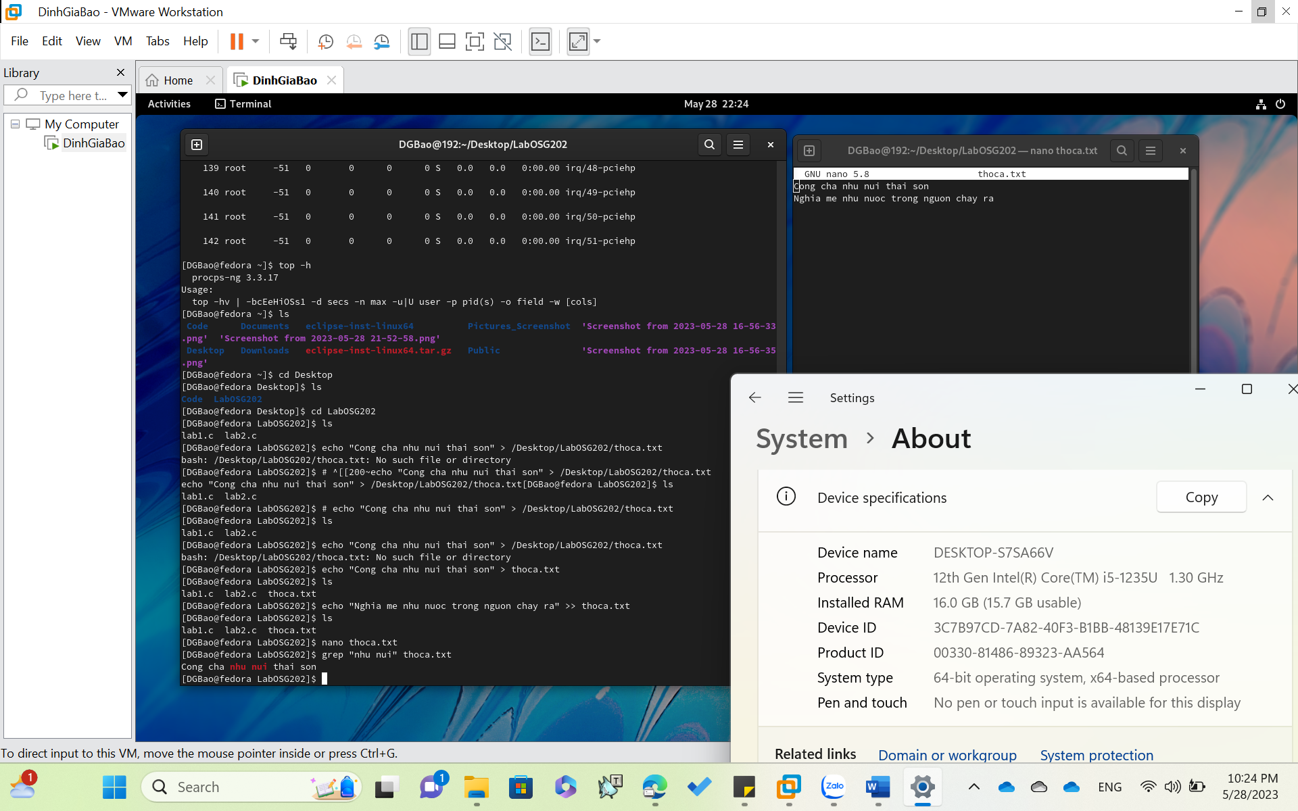

3. Submit the C/C++ files and objects files as the below content then capture the result of the program and explanation your result.

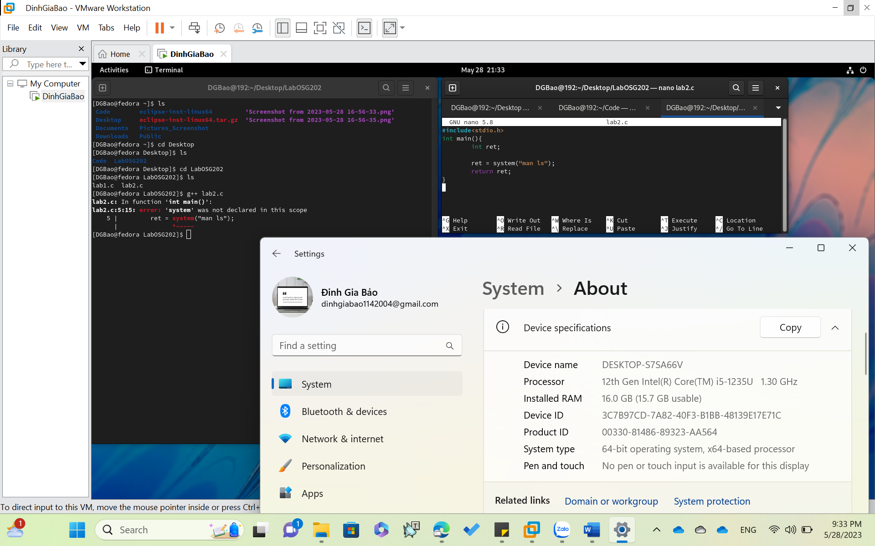

**Answer:**

* The system() function is a part of the C/C++ standard library. It is used to pass the commands that can be executed in the command processor or the terminal of the operating system, and finally returns the command after it has been completed.
* SYNTAX: int system(char command)
* The command “man ls” is passed to function system() so after
* executed, the command is implemented.
* The command “man ls” is passed to function system() so after executed, the command is implemented.